T.R.
MINISTRY OF AGRICULTURE AND RURAL AFFAIRS

REGULATORY IMPACT ANALYSIS REPORT

“Extension of the Regulation on Design of a Functioning Integrated Administration and Control System (IACS) and a Land Parcel Identification System (LPIS) in Turkey”

June 2009

AGRICULTURAL LAND EVALUATION DEPARTMENT
GENERAL DIRECTORATE OF AGRICULTURAL PRODUCTION AND DEVELOPMENT

This study was prepared by taking into consideration the Regulatory Impact Analysis Guide, described in the Prime Ministry Circular Letter No. B.02.0.PPG.0.12-010-06-3896, dated April 2, 2007.

INTRODUCTION

With its economic, social, political and technical aspects, the agricultural sector has a paramount importance, while its characteristics are different from those of the other sectors. Besides supplying raw material to the industry, the agriculture is also important as a market for the industry. It is one of the main sectors in the Turkish economy both in terms of its share in total GDP (11.9% in 2005 and 10.5% in 2006 with current prices) and employment (about 33% of the entire labor force). The agriculture sector is a major contributor to the country's GDP, exports and industrial growth.

Analyzing the agricultural support policies in Turkey, implemented prior to the decision to establish an Integrated Administration and Control System (IACS), through the process of adaptation to the EU, the following can be inferred:

- There are consistent changes out of certain direction, regarding the selection and quantity of crops within the scope of agricultural support policies and subsidy methods.

- The existence of more than one institution responsible for the implementation of supporting policies, and the lack of understanding between these institutions negatively affects the development and implementation of the aforementioned policies.

- Agricultural support policies are usually the product of sudden decisions without adequate consideration, and political interventions have no effect on the implementations.

- Lack of long term agricultural policies in Turkey prevents the farmers from taking definite and long term decisions.

This situation obviously emphasizes the necessity of serious reforms of supporting policies. It is very significant to benefit farmers and holdings fairly from supports no matter which political measure types are implemented, and to make policies accordingly.

Maintaining the existing support policies would lead to continuation of the difficulties mentioned above.

IACS as a system covers mechanisms composed for the right administration and control of agricultural supports; while securing correct payments to farmers and preventing false declarations, it enables the real farmers, in particular the farmers who cultivate their land, to receive support.

Acceptance of the same approach in Turkey will bring fundamental changes in the supports developed through agricultural policies which have been implemented up to now. (Erden, 2008)

Instead of associating all types of agricultural activities with title deed and allowing the agricultural subsidies based on verification between title deed and farmer declarations, IACS is an independent innovation to introduce other conditions such as cultivation of land and keeping the land ready for agricultural use considering the good agriculture and environmental conditions.

Outgoing agricultural support policies through certain reforms would be continued following the decision of Turkey to pursue the adaptation to the EU; preconditions set forth to this effect and current regulations of each system required to be adapted have a guiding character for the whole process. Based on this guidance, it is inherently impossible to use another system other than IACS for the right administration and control of agricultural supports.

In that respect, the Republic of Turkey is energetically determined to fulfil the acquis communautaire especially in the political field of agriculture and rural development. Pre-accession strategies adopted by EU (Accession Partnership) since 2003 have addressed the need for work on setting up an Integrated Administration System and developing a land identification system in Turkey.

Moreover, Turkey implemented an EU-funded project, namely “Technical Assistance for the Ministry of Agriculture and Rural Affairs for the design of a functioning IACS and a Land Parcel Identification System in Turkey (LPIS)” The project assessed the situation not only in terms of establishing LPIS but also IACS as a whole.

The project aimed to introduce the method and methodology concerning the IACS system, determining the investment requirements, increasing the capacity of the Ministry of Agriculture and Rural Affairs on legislative and institutional issues regarding IACS and LPIS in line with EU legislation and practices. This study has been prepared also by taking into consideration the outcome of this Project.

Following the continuation of above Project, MARA prepared and submitted a “Strategy on Establishment of LPIS and Farmer Register" in relation to 5th opening benchmark of Chapter 11.

As the most recent development. a decision was published in the Repeated Official Gazette dated 31.12.2008, concerning the implementation, coordination and monitoring of the Turkish National Programme with regard to fulfilling the Acquis Communitaire including a detailed “roadmap” from MARA on how to introduce IACS/LPIS.

Therefore, this document is prepared as an attempt to assess the impacts in setting up functional regulation and learning the effects for IACS in line with the EU acquis and practices.

I. PROBLEM DEFINITION

A. Problem Definition

- The problem considered in this Regulatory Impact Analysis is related to the farmers’support scheme administration system. There are two major shortcomings of the current system, which are also explained in more details in other sub-sections:
- The existing system is inefficient, allowing for substantial leakage of funds and exclusion of farmers from the support schemes. This is caused by the organizational and technical capacity of the system.
- The system is not compliant with the EU requirements and following numerous negotiations between Turkey and EU, Turkey committed to harmonize the existing system. This also relates to organizational and technical capacity of the system.

- Stability of the existing agricultural land, and furthermore the continuous decrease in total area due to use of land for non-agricultural purposes or misuse, required a farmers’ support scheme that would change farmers behaviour towards more responsible agriculture. The farmers’ support scheme requires an administrative system consisting of agricultural land registry (detailed inventory) and registration concerning farmers’ qualifications and provision of land usage in a planned manner.

- Moreover, Turkey is now moving towards enhancing the standards related to use of agricultural land, implementing the EU cross-compliance standards:
- Good agricultural and environmental conditions (GAEC), which must protect soils, ensure a minimum level of maintenance and avoid the deterioration of habitats.
- Statutory management requirements (SMRs) set-up in accordance with 19 EU Directives and Regulations relating to the protection of the environment, animal and plant health and animal welfare.

- When a farmer is not in compliance with GAEC, he will receive a reduced or even cancelled direct payment, depending on the severity of the non-compliance. It is required by the EU that a minimum of 5 percent of farms are spot-checked each year.

- EU member states manage the farmers support systems with the Integrated Administration and Control System (IACS), which includes detailed land inventory (Land Parcel Identification System LPIS). The current Turkish administration system is not compliant with EU IACS standards.

B. Current situation

- Turkey, using the National Farmer Registration System (NFRS) as an administrative tool, introduced direct income support system for farmers in 2001. Since then, farmers who wish to receive area-based direct income support have been registered in NFRS.

- Statistical data related to land cover (artificial surfaces, agricultural areas, forests and semi-natural areas, wetlands and water bodies) are produced by the methodology of CORINE Level I classes and published by the Turkish Statistical Institute (TurkStat). According to the outcome of the 2001 General Agricultural Census (Village General Survey) cultivable lands not in use amounted to 1,944,339.9 hectares, Permanent meadow: 1,449,312.8 hectares, Pasture (range) land: 13,167,374.5 hectares.

Used areas of land, including forests are represented in the table below:

2007
Area (hectare)
Non-permanent crops (arable crop area) | 21,979,000
Permanent crops –orchards (horticulture) | 1,671,000
Permanent crops- Vineyard  (includes all varieties) | 485,000
Permanent crops - olive groves | 753,000
Forest area | 21,189,000

Table 1.1: Statistical data for agricultural areas (Source: TurkStat)

According to those figures the total utilized agricultural area in 2007 was 39,504,686 hectares; however meadows and pastures are currently excluded from aid applications.

- There are several farmers’ support payment schemes carried out in Turkey at the moment, the description of which is provided in the next paragraph. The most important schemes are approved annually by governmental communiques and others are kept more constant based on initial decrees:

Direct payment schemes to farmers, million TL* | 2006 | 2007 | 2008
Direct payment schemes related to land size:
Direct income support scheme (DIS) | 2 653 | 1 641 | 1 710
Agricultural Insurance Payments | 2 | 32 | 55
Agricultural Reform Implementation Program (ARIP) | 62 | 24 | 45
Other support payments related to land size | - | 821 | 904
Total payments related to land size | 2717 | 2518 | 2714
Direct payment schemes not related to land size:
Deficiency payment | 1 350 | 1 844 | 1 758
Compensation payment | - | - | 80
Livestock supports | 679 | 723 | 731
Rural development supports | - | 80 | 93
Total payments not related to land size | 2 029 | 2 647 | 2 662
TOTAL DIRECT SUPPORT PAYMENTS | 4 746 | 5 165 | 5 376
* Support payments to low-income or resource-poor producers, in accordance with WTO agreements

Current situation of Agricultural Supports
The support policy tools are classified and defined in the Agriculture Law # 5488, as follows:

(i). Direct Income Support (DIS) - (valid until the end of 2008): Direct payments are area-based payments made to the producers, who make agricultural production on their lands. Payment amounts can be determined in different levels in order to facilitate the adjustment of producers to impacts of agricultural policies and the environmental protection requirements. These payments are not coupled with product or the amount of production, but depend on the land size used according to environmental and other requirements. As the current administrative system organizational and technical capacity is not able to prevent substantial leakage, it was decided to replace a part of the direct income support scheme with the deficiency payment scheme, starting in 2009, until the new administrative system will be in place.

(ii). Deficiency payment: The producers are granted deficiency payment to cover the production costs. Until 2009, deficiency payment support primarily covered the products which were scarce. Payment amounts and the products which are covered by the program are approved every year.

(iii). Compensation payments: The producers are encouraged to grow alternative products instead of products with excess supply. The producers are granted compensation payment for the income losses resulting from the cultivation of alternative products on their land.

(iv). Livestock supports: These support measures are used for race improvement in stockbreeding activities, increasing coarse fodder production, increasing productivity, specialization in agricultural enterprises and holdings, ensuring hygiene in agricultural enterprises and holdings, animal health and welfare, facilitation of animal identification system, processing and marketing of animal products, and improving control, monitoring and standardization related subjects in these animal products, and also for supporting fishery and aquaculture products.

(v). Agricultural Insurance Payments: In order to encourage the producers to insure their production materials and products, a portion of insurance premium is covered from the Government budget. These payments are related to the land size.

(vi). Rural development supports: In order to increase and diversify rural incomes; to improve rural infrastructure, land consolidation, and strengthening social structure; to protect and develop natural resources, a portion of the costs for investment projects carried in rural areas is covered by Government budget, according to the cost-sharing principle.

(vii). Agricultural Reform Implementation Program, the main component of which are Supports for the Environmentally Based Agricultural Land Protection Program (CATAK): The producers who are engaged in cultivation of agricultural lands, that are exposed to erosion and negative environmental factors, are granted supports for the protection of environment-oriented agricultural lands in a fixed period of time in order to encourage them to use their lands for vegetation, meadow, pasture, organic farming, and forestation. These supports are based on the size of land.

(viii). Other support payments: Some other support tools are also classified in the Law such as research and development, agricultural extension support, marketing supports, special storage support, quality support, market arrangement support, organic production support, annihilation support, product processing support, some input supports if necessary etc. However, most of these support tools are not used. The producers affected by natural disasters are also supported with cash or aid. The main part of these support payments is based on the size of land.

- In addition to the support instruments defined in the Agriculture Law, credit interest subsidy is also provided for the investment and management available through Banks in the agricultural sector.

- The coverage of deficiency payments was increased in 2009 in order to contribute to the productivity increase, and administration and control of the support system in the budget. It was also decided that deficiency payments will replace most of the direct income support scheme payments, until the farmers’ support administrative system capacity is enhanced, to reduce substantial leakage of funds (funds received for incompliant land plots).

- Deficiency payments for 2010 are planned to be implemented by using the developed decision support systems and considering the fulfillment of Good Agricultural and Environmental Conditions (GAEC).

Inefficiency of farmers’ supports administrative system, allowing for substantial leakage of funds and exclusion of farmers from the support schemes, caused by the organizational and technical capacity of the system

- The efficiency of the current farmers’ support system related to land size, was assessed during the EU funded project “Technical Assistance for the Ministry of Agriculture and Rural Affairs for the design of a functioning Integrated Administration and Control System (IACS) and a Land Parcel Identification System (LPIS) in Turkey” (TR0402.08/002), carried out in two pilot regions: Ağrı and Tekirdağ. This project designed and tested basic elements of the new system in the pilot areas, to understand the effectiveness and sustainability of the system. Graphical illustrations of the status of farmers receiving support in those two regions, based on the findings of the project, are given below. It is remarkable that there are non-active farmers receiving support.

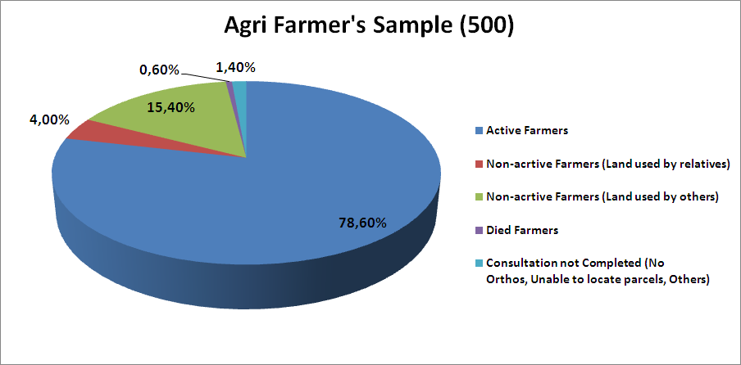
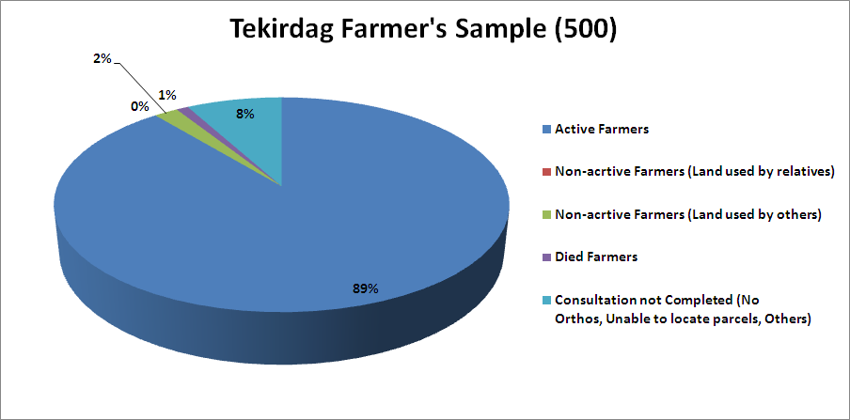

Figure 1.1: Status of the farmers in the sample of Tekirdağ and Ağrı

- Some other interesting figures shown on the following chart, as result of the consultation with farmers, relate to differences in the areas declared by the farmers and those actually measured on the orthoimages. After the precise digitalisation of the boundaries of the used agricultural parcels as they were declared by the farmers, it could be observed that the differences were quite remarkable and most of them were due to mistakes in the location of the declared parcels during the consultation procedure (specifically, during the on the spot check at Tekirdağ, differences for parcels were found, which were located in wrong places) and the tendency of the farmers to declare more area in case of uncertainty of the real cultivated area. The use of a complete database, the execution of some on line cross-checks during the procedure of parcel declaration, the use of a more sophisticated and integrated IACS software accompanied with on the spot checks could detect those differences.

Fig 1.2 Total Area Differences in the sample of Tekirdağ

- The existing National Farmer Registration System is based on statements made by farmers. The support application includes: letter of application, farmer registration form, identity card, ID number, tax number, farmer certificate and land ownership certificate or rent contract. Farmers submit these documents to District/Province Directorates of MARA within application period. Applications are collected by 81 Province points and 803 District points. Ministry staff has been charged with support implementation. At the first entry to NFRS, information mentioned above is registered and then, each year, this information is confirmed by farmers. If there are any changes in the information, farmers should declare those changes. In case no changes are identified, farmers fill in only crop information. Current administrative system is considered very burdensome for farmers, the main reason being long lasting application processing procedures. This was the main reason of the decline in number of total farmers receiving support in 2008 by 8% (see the table in Determining Parties to the Problem section).

- There are many cases when the farmer does not live in the province, but appears only once a year to submit the application and receive the money from the system. His land is left for use by other farmers or derelict (see Fig.1.1 above). Moreover, there are also errors in measuring land plots and cases of deliberate over-reporting by farmers of the land size. Partially, this situation was revealed in Fig. 1.2. This evidence points to the problem of leakage of funds, i.e. funds paid for land plot which is not used properly or derelict. According to Fig. 1.2 the leakage is about 8.1%. Additionally, in April 2009, MARA disseminated 81 questionnaires to province staff asking to estimate the level of leakage (see annex 4). The average answer was 6.1%. However, these estimates are based on the old system, and were not revealed by simulations carried out during the TR0402.08/002 Project. Therefore we can say that the real number is higher. In this report we will stick to 8.1% leakage, which is the leakage that can be realistically eliminated by the new system.

- Fig. 1.1 points also to the problem of exclusion of certain farmers, which are farmers not accepted for application within the existing administrative system. These are farmers that use land but do not hold the title deed, i.e. farmers that do not own the land or lack the capacity to obtain such documents. This is a social problem as it affects mainly disadvantaged farmers. Moreover, if we compare the total agricultural land (see paragraph 4 in Problem Definition section) with the land receiving support (see the table in Determining Parties to the Problem subsection), 35% of land does not receive support. There are no studies that can differentiate between those not willing to get support and those not able to get it because of the current administrative system. However, we can assume that the percentage of those unable to receive it is very high, at least 17.5% (half of 35%). According to consultation with province staff mentioned above (see also annex 4) the exclusion was estimated to be about 12.3%. However, taking into account the low response rate of the province staff and the fact that they would be biased in their responses as they are part of the current administrative system and so not inclined to recognize its inefficiency, we consider the first estimate (17.5%) as more realistic.

- In NFRS, cross checks are implemented according to information of Central Population Management System (MERNIS) and land registry documents from Land Registry Offices. Data about parcels are sent to District Land Registry Offices every 2-3 years and all data are checked. However checks are mostly based on verification between the title deed and farmer declaration and may not cover a whole spatial control (lack of digital cadastral data at national extend).

- Following the completion of an application, controls are implemented via approved documents (land ownership document, farmer certificate), approval of village headman and members of the village committee, spot checks with sampling method in cadastrized areas by MARA staff, and area determination works in lands without cadastre. However, incompatibility of records with LPIS standards to make all the controls foreseen in the IACS prevents the realization of cross-checks based on reference parcels and GIS. One important remark is that in most cases, confirmed by research carried out under EU funded TR0402.08/002 project, one agricultural parcel consists of many cadastral parcels, whereas farmers declare that as one agricultural parcel (see Fig.1.4 for visual representation). During the EU funded TR0402.08/002 project, in most of the researched cases the area used in reality and recognized on the orthoimages by the farmers was smaller than the area referred on their ownership deeds, and used under farmers’ support scheme.

Harmonization with EU

- Turkey has committed to harmonize with the EU legislation. An important area of harmonization are “rules for direct support schemes under the common agricultural policy and establishing certain support schemes for farmers” (COUNCIL REGULATION (EC) No 1782/2003 of 29 September 2003), which provides for the need to harmonize IACS within EU countries. The evidence about commitment can be seen in section on “Determining current governmental policies and legal regulations in connection with problem area”.

- In 2007, Turkey implemented the EU-funded project TR0402.08/002. The project assessed the situation not only in terms of establishing LPIS but also IACS as a whole.

- Currently NFRS is used for Direct Payments to Farmers. It consists of registration of applicant farmers, identification and registration of payment entitlements, a computerized data base and aid applications which are similar to basic components of IACS. Despite of this similarity, NFRS cannot be fully assumed as the best tool to base the entire IACS system on, as already declared during Screening Meetings, under the above mentioned EU project. Lack of reference data necessary to make all the controls foreseen in the IACS, incompatibility of records with “LPIS”, and lack of cross-checks based on reference parcels and GIS are differences from the IACS.

- It is necessary to introduce IACS in Turkey based on the rules settled in the Community legislation during the harmonization process in order to eliminate the gaps mentioned above.

C. Determining Parties to the Problem

- As the problem deals with farmers’ support schemes and harmonization with EU system, the following stakeholders will be affected:
- Turkish farmers
- Turkish Farmers Support Schemes Policy and Administration Bodies
- EU member states and administrative bodies

- The main stakeholders are farmers as the existing and potential beneficiaries of the existing farmers’ support scheme:

 | 2006 | 2007 | 2008
Total no. of farmers* | 4 406 983 | 4 406 983
Total agricultural area related to farmers, million ha* | 40.5 | 39.5
Farmers receiving support** | 2 594 928 | 2 591 944 | 2 380 284
Area receiving support, million ha** | 16.3 | 16.2 | 15.8
* Source: TurkStat (total number of farmers according to agricultural census of 2001)
** Source: MARA

- Farmers’ support schemes Policy and Administration bodies (participating to system implementation and administration), includes the members of Agricultural Support and Guidance Board specified in Law # 5488. The members of the board include the Undersecretaries of the Ministry of Agriculture and Rural Affairs, the Ministry of Finance, the Ministry of Industry and Trade, the Ministry of Environment and Forestry, the Undersecretariat of the State Planning Organization, the Undersecretariat of Treasury, the Undersecretariat of Foreign Trade and the General Director from the Ministry to be designated by the minister’s approval under the chairmanship of the Minister of Agriculture and Rural Affairs.

- Personnel involved at the moment in the administration of farmers’ support scheme. There are 884 data entry points, of which 81 in Province Directorates (PDs) and 803 in District Directorates (DDs). About 8,000 personnel of MARA are working in the NFRS related activities including receipt of application and data entry. The NFRS administrative system is shown in Figure 1.3.

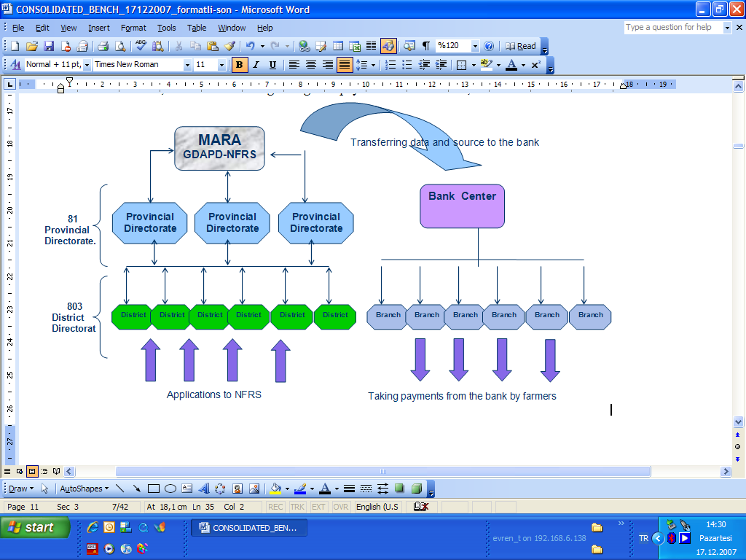
Fig 1.3 Workflow chart regarding payments in NFRS

- In negotiations with Turkey, the EU is represented by the Permanent Office of Secretariat General for EU in Ankara.

D. Current Governmental Policies and Legal Regulations in connection with Problem Area

- This section provides an analysis of official reports and legislation related to the problem being considered in this Regulatory Impact Analysis:

- 2006 Progress Report (the report of the European Commission on progress of Turkey upon Accession). The Report stated that “Agriculture Law creates the legal basis for certain management systems (Integrated Administrative Control System, Farm Accountancy Data Network) necessary for implementation of the acquis. Initial steps were taken to prepare the implementation of the Integrated Administration and Control System (IACS). The National Farmers’ Register System is not compliant with the EU regulations.”

- 2007 Progress Report (progress of Turkey upon Accession). The Report stated that “The preparations for the introduction of the Integrated Administration and Control System (IACS) are ongoing with a pilot implementation in the frame of the EU pre-accession assistance. The National Farmers’ Registration System (NFRS) is in line with the EU legislation. However, about 10% of farms remain unregistered. Further development of the system of land identification and the NFRS to prepare for controls on agricultural land is necessary.

- 2008 Progress Report (progress of Turkey upon Accession). According to the Report “The government’s announcement of the intention to scrap decoupled area payments and replace them by coupled payments remains a cause for concern. This would lead to Turkey’s agricultural policy drifting away from the reformed Common Agricultural Policy (CAP) and from the principles of competitiveness and market orientation. Turkey has advanced in preparing a strategy to develop the system of land identification and a farmers’ register, as well as a strategy to develop agricultural statistics in line with the EU requirements.”

- 2003 Accession Partnership, where “preparation of a strategy for introduction of the LPIS in Turkey and implementation of IACS” in the whole country for the management of direct income payments to farmers and for selected Rural Development Project measures” are defined as short and medium term priorities respectively.

- 2008 Accession Partnership where “continuing development of the system of land identification and the National Farmer Registration System to prepare for controls on agricultural land” is defined as a medium term priority.

- Agricultural Law # 5488:

- Article 3 defines “Integrated Administration and Control System” as a system which consists of land parcel identification, farmer registration, animal identification, control and database, and which provides the control and registration of agricultural subsidies.

- Article 20 (Implementing Principles of Agricultural Supports) para (d) stipulates that the integrated administration and control system shall be used for all support payments to be granted to producers.

- Provisional article 2 stipulates that “Until establishment of the integrated administration and control system, the support payment related to plant production shall be based on the farmer registration system.”

- Agricultural Strategy Paper (2006-2010):

- Direct income support payments will be made upon unit payment amount (TL per hectare) that is determined every year, for agricultural lands cultivated for the purpose of agricultural production. Payment amount will be determined at different levels in order to facilitate producers’ alignment for purposes of agriculture policy.

- In parallel with the development of a farmers’ registration system, payments will be made to producers that cultivate specific crops. However, area based payment criteria will not be changed.

- 9th Development Plan (2007-2013):
Problems related to the quality and quantity of agricultural statistical data will be eliminated through the consolidation of different information collection and processing systems, which are based on this data, and in a structure similar to the Integrated Administrative and Control System used in the EU. In addition, activities related to the completion and digitalization of cadastral information, which enables the operation of land markets in the agricultural sector and constitutes an infrastructure for the administration and control of agricultural policies, will be finalized.

- National Program for the Adoption of the Acquis (NPAA) adopted by Decree # 2003/5930 on Implementation, Coordination and Monitoring of the Turkish National Program regarding the European Union Acquis responded accordingly. Even though there is no legislation yet totally corresponding to IACS as provided in Council Regulation # 1782/2003, Turkey has already implemented important legislative steps in the direction of the ultimate reform of the Common Agricultural Policy (CAP). Agricultural Law # 5488 of 2006 founded already the basis for the introduction of IACS in Turkey for the management of all the payments to farmers.

- The Decision published in the Repeated Official Gazette dated 31.12.2008 regarding the Implementation, Coordination and Monitoring of the Turkish National Programme related to fulfilment of Acquis Communitaire provided for the need to draft three Turkish legislations related to supervision of agricultural land, improving land identification and National Farmer Registration System. According to the deadline sequence, these are (i) Draft By-Law on Implementation of the Integrated Administration and Control System (IACS), (ii) Draft Law on Implementation of a Decoupled and Simplified Agricultural Support System, (iii) Draft Law Amending the Law on Agriculture and Rural Development Support Institution.

- Although Turkey has already implemented legislation covering many fields, which farmers have to respect under cross compliance obligations, further elaboration is required since control and compatibility of these rules with the acts enumerated in Council Regulation (EC) 1782/2003 lag behind. With the introduction of necessary legislation in line with the EU acquis, especially on Statutory Management Requirements (SMR) and Good Agricultural and Environmental Conditions (GAEC) further checks with respect to cross compliance conditions shall be defined and awareness of farmers about their obligations shall be increased.

E. Stating justifications for intervention

- Turkey has changed its agricultural policy in the direction of decoupling its agricultural support policy from production. Farmers who wish to receive direct income support given on the basis of agricultural land are registered in National Farmer Registration System (NFRS). NFRS maintains data on farmer (e.g. name, date of birth, citizenship identification number, etc.) and land information (whether he/she is the owner of the land, used area, type of use, produced crops, etc.) Administrative cross-checks are performed with regard to the land title information in order to avoid double claims for the same cadastral parcel. However, this check is mostly based on verification between the title deed and farmer declaration (lack of digital cadastral data) and may not cover a spatial control in some cases. Moreover, the system allows leakage of funds (support paid for incompliant land) and exclusion (many disadvantaged famers cannot apply). And finally, parcel identification system in Turkey does not meet LPIS standards of EU.

- National Farmer Registration System (NFRS) weaknesses/incompliance with IACS provisions:

- Lack of LPIS at country-wide scale and lack of ortho imagery covering all Turkey in IACS/LPIS standards.
- Lack of some control procedures with remote sensing and on the spot checks in a way that is stated in the EU, as a consequence of lack of such provisions in the legislation.
- Lack of LPIS causes problems in checks because it is also used as the main tool in revealing discrepancies during paying procedures.
- Lack of utilization of the Remote Sensing (RS) system at acountry-wide scale. According to the EU legislation selected farmers (at least 5 % of all applicants) are subject to on-the-spot control. Some of the declared information (area and land use) is checked using RS first; this method is based on the analysis of up-to-date satellite images of the territory. Should discrepancies be found, an inspector is sent to the location to perform a personal inspection.
- For mainly incentive reasons, direct income schemes are differentiated especially in animal production, forcing the administration to demand a lot of detailed information from the farmers. That makes the application procedure rather complicated, open to mistakes and forces the controls to go into many details. It is not enough, for example, to identify only the acreage a farmer cultivates, but the crops grown and the permanent crops and pastures have to be distinguished as well.
- There are numerous cases, when the farmer does not live in the province, but appears only once a year to submit the application and receive the money from the system, his land is left for use by some other farmers or derelict (Ref. to Figure 1.1).
- More than 1.2 million cattle holdings have been entered into the computerized database. The studies on the improvement of cattle identification and registration (I&R) is underway. Introduction of I&R for sheep and goats, and inclusion of the meadows, pastures and range lands in the direct payment schemes are very important.
- One important remark is that in most cases during the Project (TR0402.08/002) studies, in which one agricultural parcel was consisting of many cadastral parcels, the farmers identified and declared that as one parcel.

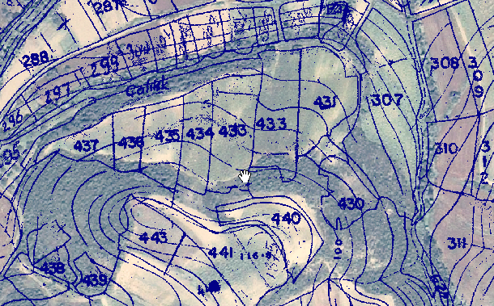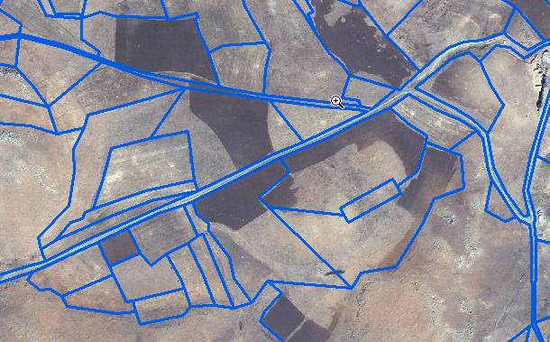
Figure 1.4: Discrepancy between cadastral data and reality shown by orthoimages (left: Tekirdağ, right: Ağrı)

In both cases the number of the agricultural parcels that actually were used by the farmers was quite a lot smaller than the one resulting from the NFRS database. The explanation is that a lot of cadastral parcels (which were used as reference in NFRS) in reality are one physical agricultural parcel cultivated by the farmer.

Cadastral work is completed in 86% of rural areas in Turkey. Digitization of the cadastral maps is currently under way and a small amount of total area has already been digitized in this framework, with a priority in urban and semi-urban areas. Although there are some pilot projects, data on land parcels are generally kept on paper basically for registration of ownership.

- In the case of continuity of the current system, the following problems will be valid: LPIS, the most important cornerstone of the system will not be implemented, it will not be possible to introduce the full functioning IACS, there will be infringements and misuse of land by systematic minimum control not in line with the EU acquis, pastures will not be included in the system, more less-favoured areas and landscape features will be excluded, the verification of declared parcels will be less effective, identification of land will continue to be based on the owner deeds and farmed parcels will not be effectively identified, the support application procedures will continue to be lengthy. There may be an increase in the number of land owners (instead of user/farmer) who directly takes the subsidy though he/she doesn’t contribute to the agricultural production procedure. Deficiency in control procedure in this case, will form an additional burden on the national budget.

- Based on the fragmentation of agricultural parcels caused by heritage processes, smaller parcels and holdings will very often negatively outpace the land consolidation efforts. This can be supported by introducing a dynamic development of minimum parcel definition and minimum farm definition in the law, to help prevent the development of ever smaller parcels/holdings in the system.

II. DETERMINING TARGETS

- In drafting measures to solve the problem described in this report, MARA is pursuing the following targets:

- Harmonize with EU IACS system by 2012 (committed date).

This is an important objective, as not putting the appropriate administrative system in place could jeopardize the proper functioning of the farmers’ support schemes after the EU accession. Having an inefficient system in place would influence the funding received from the EU.

- Increase the efficiency of farmers’ support administrative system:

  - Reduce leakage of funds. Leakage of funds makes the system inefficient. First of all leakage is caused by inaccurate measurement of land declared by the farmers, which results in over-reporting of land size by farmers. Secondly, there is a share of land plots receiving support, but which are not used at all or used improperly by farmers (ineligible land plots). Until now, the leakage was assessed in 2 provinces (Tekirdag, Agri) through sampling method used under the EU funded project (TR0402.08/002), and it was estimated at a level of 8.1% (Tekirdag). Therefore an important objective of the Ministry of Agriculture is to reduce the leakage by 8.1%.

  - Reduce exclusion of farmers. Excluded farmers are the farmers that cannot claim support funds, because of lack of deed/statement of rent on land or because they do not own the land. The exclusion rate was partially assessed in 2 provinces (Tekirdag, Agri) under the EU funded project (TR0402.08/002). In general, it is assumed to be around 17.5% (see problem definition section). The objective of MARA is to reduce it at least by half.

- Reduce the administrative burden on farmers.

The existing burden on farmers includes requirements to present different documents every time they submit the application for funds. Moreover, the burden also includes the processing time for applications, which results in delays in payments to farmers. It is believed that because of the application burden the total number of farmers benefiting from the support reduced by 8% in 2008 (see problem definition section). Therefore, while revising the existing system, it is important to reduce the administrative burden and improve the application procedures.

III. DETERMINING ALTERNATIVE SOLUTION METHODS

- In this section, the following solutions to solve the problem and achieve the targets are described:

- Option 1: “Do nothing”

- Option 2: Harmonize with EU Integrated Administration and Control System (IACS), based on best practices of EU countries.

- Non-regulatory alternatives are not considered as the problem deals with administration of state payments to farmers, which requires regulation.

- Only one regulatory option in setting up the farmers’ support system was considered, which is a combination of best practices from EU countries regarding features of Integrated Administrative and Control System (IACS). This is explained in more detail in the ‘Problem Definition’ section, in the Strategy Regarding Identification of Agricultural Lands and How to Develop the National Farmer Registration System and in the Final Report (August 2007) on Technical Assistance for the Ministry of Agriculture and Rural Affairs for the design of a functioning Integrated Administration and Control System (IACS) and a Land Parcel Identification System (LPIS) in Turkey (TR0402.08/002).

Option 1: “Do nothing”

- “Do nothing” option means continuing to apply the existing farmer support schemes administration system: National Farmer Registration System (NFRS). This system was described in more details in the “Problem Definition” section.

Option 2: Harmonize with EU Integrated Administration and Control System (IACS)

- This option means implementation and operation of the Integrated Administration and Control System (IACS) complied with EU standards while observing the best practices applied in EU Member States.

- As IACS is an administrative tool to assist farmers’ support policies implementation, its development will be synchronized with the development of other system components, such as cross-compliance development. The scope of cross-compliance (the rules with which the farmer has to comply) comprises two components: the “statutory management requirements” (SMRs) and “good agricultural and environmental condition” (GAEC). SMRs are provided in special directives. For GAEC, the Member States have to define minimum requirements for all standards on the basis of the framework set up in Annex III of Council Regulation (EC) No 73/2009, except those that are not relevant to the national context.

- Implementation of the administrative system in a large country like Turkey can only be successful with further technical assistance. The IACS / LPIS Project (TR0402.08/002), identified the need for the following future projects:

- Establishment of LPIS. Here the first duty is the acquisition of most up-to-date images for the whole country. It might be satellite or aerial images however satellite images might cause fewer problems and be more easily available. Then the digitalization of the land parcels shall be established and the LPIS database shall be created. In line with orthoimages taken and digitalization process, farmer consultations for the linkage with parcel identification will be carried out by MARA under the supervision of the project experts.

- Implementation of the paying agency structure using IACS / LPIS. As MARA will be the future paying agency, the Institution will need to be supplied with the necessary hardware and software, office equipment and other equipment necessary for on-the-spot checks, the guidebook for IACS procedures and training of staff against accreditation criteria.

- Establishment of permanent crop register. Agricultural parcels occupied by permanent crops (hazel and other nuts, tea, olive groves, vineyards, citrus etc.) shall be registered to enable the administration to create GIS parcels, to count trees and evaluate market capacity.

- Development of cross-compliance rules and their implementation. EU legislation requires the farmers to meet the rules of cross compliance. Cross compliance sets requirements for farmers receiving direct payments to respect public, animal and plant health, environment and animal welfare (statutory management requirements) and good agricultural and environmental conditions (GAEC). Therefore, Turkey shall define relevant cross-compliance rules and take necessary legislative actions. Procedures for controlling the respect of cross compliance shall be elaborated, an information campaign addressing the administration and farmers shall be developed and implemented.

- Training the staff needed to use the IACS / LPIS as the administration tool. The IACS / LPIS can only be successfully implemented throughout Turkey if the relevant personnel are systematically trained to use the new tools of administration. Therefore, MARA staff will be trained on the use of IACS/LPIS and material for further training shall be prepared.

- Development of risk management and on-the-spot-controls. In the IACS procedures these duties must be finished before any payment to farmers can be done. At least 5 % of the applications get a special control besides the general administration control and the cross checks in the application routine. Therefore, risk evaluation and management system shall be established, guidebooks for on-the-spot-controls customized for Turkish conditions shall be prepared, staff shall be trained for on-the-spot-control controls and necessary measures shall be taken for ensuring the sustainability in training.

- Maintaining and accelerating the software for LPIS and IACS. The software and the hardware for running the IACS / LPIS is the most critical part of the system. It has to be available and ready to work at any time, it has to be efficient and safe and, above all, friendly for the user in the application. Therefore, attention has to be given to maintenance, innovation and enhancement. For this purpose the criteria and other actions for maintenance, innovation and enhancement of the system for several years shall be developed.

- Following is the timetable for implementation:

No | Requirements | Year
1 | On the job training for 35 personnel who studied during IACS and LPIS Pilot Project (TR0402.08/002) to increase their experience and upgrading them to trainer status via experimenting implementations in 3 member states | 2009
2 | Digitalization of LPIS in Turkey to create a new parcel identification system using remote sensing | 2010-2012
3 | Project on cross compliance | 2010-2011
4 | Development of the Paying Agency part for single payment scheme (SPS) using IACS | 2011-afterwards
5 | Training the staff of MARA for implementation of IACS and LPIS as management tools | 2010-2011
6 | Introduction of IACS / LPIS for permanent crops to create a special register for hazel and other nuts, tea, olive groves, vineyards, citrus and other fruit plantages | 2011-2012
7 | Development of a concept for maintaining and accelerating software for LPIS and IACS | 2011
8 | Methodology of on the spot control, risk evaluation and training of staff for on the spot control | 2011-2012
9 | Personnel recruitment to IACS Administrative Unit | 2009-2012

- Finally, IACS will be adopted by a regulation: By-Law on Implementation of the Integrated Administration and Control System (IACS) and a package of amendments to other legislation.

- Technical comparison of options. The table below provides a technical comparison of both options, according to the features of integrated administration and control system for farmers support, defined by EU Council Regulation No. 1782/2003.

Technical components | Option 1 (current system) | Option 2 (proposed system)
Computerized database | YES *  Farmers who wish to receive area-based direct income support are registered in the NFRS. It consists of tabular personal information of farmers, land information (tabular information of cadastral parcels where exists), other assets (livestock, input etc.), crop pattern in farmer level and average yield of crops at district level. | YES  All records subject to aid applications will be recorded under one system consisting of tabular and graphic information at the same time. Besides tabular information described under option 1, there will be a graphic interface, i.e LPIS, which shall be managed in GIS (computerized geographical information system), linked to the IACS database (Council Regulation 1782/2003 repealed by 73/2009 ), and shall include regular updates.
Identification system for agricultural parcels | NO**  Although NFRS maintains data on land information (whether farmer is the owner of the land, size of used area, type of use, produced crop, etc.), it is based on title deed information rather than on an identification system for agricultural parcels. | YES  Identification system for agricultural parcels means the introduction of LPIS  All agricultural lands shall be clearly identified, digitized and split into physical blocks first. After consultation with farmers, the results shall be integrated as agricultural parcel borders. During the whole procedure, LPIS shall be developed by computer aided photo interpretation (CAPI) in GIS environment as defined in EU Regulation
System for the identification and registration of payment entitlements | YES*  For the payments to be conducted through the use of NFRS, information subject to transfers is reported to the bank through a centralized database in electronic form, which includes environment. On award of the national identification number, farmers have a bank account automatically activated by the bank. | YES  The system for the identification and registration of payment entitlements allows the paying agency to direct and immediately consult the data for the previous three calendar years. Use of payment entitlement gives the right to receive payments in the single payment scheme.
Aid applications | YES*  NFRS is based on applications made by farmers, which include: letter of application, completed farmer registration form, identity card, ID & tax numbers, farmer certificate, land ownership or rental contract. Farmers submit these documents within application period to District/Province Directorates of MARA, which enter the information into the database. Ministry staff is responsible for implementation and data entrance. Following the completion of application, controls are implemented via approved documents (land ownership document, farmer certificate), approval of village headman and members of the village committee,  However, incompatibility of records with LPIS standards to make all the controls foreseen in the IACS prevents the realization of cross-checks based on reference parcels and GIS. | YES  Aid applications shall contain the main information needed for the payment and its verification such as declaration on all agricultural parcels, number of payment entitlements etc. A single application for all payment schemes may be used.  For the aim of payment entitlement and agricultural parcel identifications, pre-printed application forms shall be distributed to the farmer in accordance with the rules defined in Regulation (EC) No 796/2004. Preprinted application form containing the detailed map of the declared parcels with supplementary background information (directly accessible in computerized GIS environment) such as orthophotos, topo-names (local names taken from topographic maps), other supplementary features and detailed attribute information of the parcels from the previous year shall form the basis of this process.
Integrated control system | NO  Administrative cross-checks are done with regard to the land title information in order to avoid double applications for the same cadastral parcel, which are mostly based on verification between the title deed and farmer declaration (lack of digital cadastral data) and may not cover a spatial control in most of the cases. In NFRS, cross checks are implemented according to information of Central Population Management System (MERNIS) and land registry documents from Land Registry Offices. Therefore cross-checks are not fully compliant with the EU regulations | YES  LPIS shall be managed in GIS environment (computerized geographical information system) linked to the IACS databases. GIS will be used for reference parcel checks in order to identify the possible cause of anomalies, including errors and overdeclaration of land plot size, and use programmed logical analysis and automated reporting. Early detection of anomalies related to reference parcels, in real-time at data entry, will be solved while the applicant is immediately available to clarify the issue
Single system to record the identity of each farmer who submits an aid application | YES*  The current legislation on registration requires farmers to register and declare the parcels in agricultural use. This database includes farm identification code and registry of parcels (based on tabular information and not spatial) on the basis of cadastral description and title deeds.  Current database includes registry of farmers linked with their cadastral parcels only by tabular/numeric means and not through any digital spatial linkage. | YES  Under this option, the registration system will include information about the agricultural holdings and farmers. A lot of information will be inluded into the system, such as: ownership status, crop type, land size (visually verifiable) etc.  In short, all aspects of current registration system will be included in addition to a permanent visual interface (GIS segment) which shall be developed for enabling the visual control of declarations and real-time anomally detection within the system.

* As described during the screening meetings, NFRS is being used for Direct Payments to Farmers. It consists of registration of applicant farmers, identification and registration of payment entitlements, a computerized database and aid applications which are similar to basic components of IACS, except for lack of reference data necessary to make all the controls foreseen in the IACS, incompatibility of records with “LPIS”, lack of integration between Animal I&R System and NFRS in MARA and lack of cross-checks based on reference parcels and GIS are different from IACS. Also current checks are mostly based on verification between the title deed and farmer declaration (lack of digital cadastral data) and may not cover a spatial control.

** In view of future preparation for IACS, it is important to emphasize that the basic unit of the current system is far from the agricultural parcel concept aimed to be structured through LPIS generation. The pre-registered parcels in NFRS are different from agricultural parcels of LPIS.

IV. BENEFIT AND COST ANALYSIS

Determining Groups and Fields Affected by the Regulation:

- There is a range of stakeholders who will be affected by changes in the farmers’ support administrative system:

- Farmers, both those benefiting within the existing system and those farmers deserving eligibility according to EU regulations but excluded from the system.
- Public authorities (MARA, farmer organizations, local agricultural government authorities etc.) involved in implementation and administration of the new system
- Authorities involved in the planning and administration of Turkish State Budget

Option 1: “Do nothing”

- Costs of Option 1. It is considered that if option 1 were chosen, the situation will worsen:

- The pressure on the administration system will increase and respectively the costs of system operation will increase as well. However, these costs are considered insignificant compared to the increase in operating costs in Option 2, and therefore they were not assessed.
- The situation will be the same with costs related to compliance of farmers with the administrative system.
- There will be a slight increase in the leakage of funds, i.e. funds paid for agricultural land which do not comply with agricultural quality requirements. These costs are generated both by errors made by farmers when estimating land plot size and also by deliberate misreporting of the land size by farmers. As the potential increase in leakage is considered insignificant, it was not assessed.
- After accession, the EU funding of Turkey’s agricultural support schemes will be lower than in the case of option 2, due to not achieving full harmonization and a reliable administration system.
- Other potential costs are associated with the increase in exclusion, which means that certain compliant areas will become ineligible for support. The costs here are represented by the decrease in the quality of environment, as those areas will stop complying with the environmental standards after stopping receiving support. However, these costs are being compensated by funds not allocated for those environmental goods. If we consider that the value of improved environmental quality is equivalent with the amount of payments, which are intended to be compensation to the farmers for those goods, than this cost is offset by the reduction in state budget spending. Therefore these costs are more distributional costs, but are important as they affect disproportionately the more disadvantaged/poor farmers.

- Benefits of Option 1. No benefits are expected from option 1.

Option 2: Harmonize with EU Integrated Administration and Control System (IACS).

Costs of Option 2

- It is considered that if option 2 is chosen, the following costs will be incurred:

- Additional investment in administrative system
- Increase in administrative system operational costs

- Implementation investments. In order to finalize and launch the IACS system, a set of investments are necessary over a 4 year time period (2009 – 2012). These investments are represented in the table below. However, most of these investments are expected to be covered by EU projects’ funds. The only investment expected from the Turkish State Budget is 12.5 million Euros, which are expected to be invested during the last year of implementation (in 2012).

Investments | Estimated amount,  mill Euro | EU projects contribution,  mill Euro | Turkey contribution,  mill Euro
LPIS Digitization | 49.2 | 40.3 | 8.9
IACS software and SPS PA | 14.5 | 11.0 | 3.5
Introduction of IACS / LPIS for permanent crops | 23.4 | 23.4 | 0.0
Training Staff for IACs and LPIS | 1.9 | 1.8 | 0.1
Methodology of risk evaluation, on-the-spot-control (OSC) and training of staff for OSC | 0.4 | 0.4 | 0.0
Development of a concept for maintaining and enhancing software for LPIS and IACS | 0.1 | 0.1 | 0.0
Cross-compliance | 0.4 | 0.4 | 0.0
TOTAL | 89.9 | 77.4 | 12.5

- On average new member countries have invested per applicant 25 Euro and per 1000 ha area 2770 Euro. On this basis the estimated investments for introduction of the IACS in Turkey are quite reasonable (30 Euro per farmer and 2009 Euro per 1000 ha) (source: TR0402.08/002).

- IACS administrative costs. It is estimated that the annual extra amount of budget resources required for additional personnel to run the IACS system is 7.5 mill Euros. This amount will be covered by Turkish state budget (source: TR0402.08/002).

Benefits of Option 2

- The following benefits are expected from option 2:
- Decrease in costs related to compliance of farmers with the administrative system
- Reduced leakage of funds
- Environmental benefits
- Social benefits
- Administrative benefits
- Positive impact on completion
- Positive impact on EU harmonization/accession

- Decrease in costs related to compliance of farmers with the administrative system.
As the IACS system is more advanced, there will be standardized applications generated together with a land plot map, which the farmers will just need to sign. Also, farmers will not be asked to present additional documents. As the other benefits generated by option 2 are significant, this benefit was not assessed in detail.

- Benefits related to reduced leakage of funds.
Funds provided for agricultural land which do not comply with necessary standards, are wasted. Therefore a reduction in leakage will represent savings (benefits). However, leakage can be also reduced if improperly used agricultural areas identified start to be cultivated properly by the farmers wanting to keep receiving the previous payments. In this case it is still a benefit, as by spending the same money compliance is achieved and therefore more environmental benefits are generated. As in the costs section the assumption here is that the value of environment benefits is equivalent with the amount of payments made by the government for those benefits. According to surveys carried out under TR0402.08/002 project, some farmers provided inaccurate information about the cultivated land plot. The share of errors and over declaration of land size was about 8.1% (see Figure 1.2 in problem definition section). The total support funds related to size of land was 2,714 million TL in 2008 (about 1,300 million Euros) (see section on problem definition). If this percentage is multiplied by the amount of support related to field area we can estimate the amount of leakage: 150.3 mill Euro per year, within the current system. As the leakage was revealed by piloting the new system in two regions, it is assumed that option 2 will eliminate this leakage. Moreover, after accession, if proper IACS is implemented, Turkey might receive up to 8.5 bill Euros as farmers’ support scheme from EU budget (source: TR0402.08/002).

- Environmental benefits.
Option 2 will generate important environmental benefits, which are not easy to quantify but are assessed qualitatively below:

- Reducing leakage and exclusion would lead to increased compliance with environmental standards. In order to be able to quantify impacts, it was decided to attribute to the environmental goods the value of payments under support schemes. However, if environmental goods are more valuable, than we can mention that additional value under this impact.

- Any work that changes the structure of agricultural land, such as land consolidation projects, new structures like highways etc., could result in the need to update the LPIS and will be monitored henceforth. Dissemination of knowledge (implementation plan and project scope) about large scale projects shall be provided during Coordinating Committee Meetings and Budgetary Meetings between organisations.

- Within the frame of agri-environmental measures (GAEC rules), it is important to continue agricultural activity only within the limits of legal land-use borders (not conflicting with forest border, public land etc.). However, currently in many cases agricultural activity can invade forestry zones - farmers destroy natural forest and illegally expand their agricultural land. So implementation of the system will foreclose this unfair (against the environment) and illegal condition. Please see the left-hand side of Fig 1.2 in order to observe parcel changes of land use (forest) when the land is used for agricultural purposes instead of its legal and original nature (parcel no 430, 438 and 439).

- There will be some statistical methods in order to determine the rate of change in land use and hence the need for updating the system. The 75% - 90% rule shall be applied every year in order to identify changes in the land use over the time in a specific region and shall be put into consideration immediately after the first year of using the LPIS and the completion of the submission of farmers’ declarations. According to the above rule at least 75% of reference parcels in a certain region shall be eligible for payments for at least 90% of their area. Using statistical tools, application of this rule shall be checked for the whole country. In cases that for a specific region the rule is not valid, the boundaries of the reference parcels shall be re-digitized. This means that validation of current disbursement will only be awarded to statistically and environmentally proper areas.

- Since EU legislation and Turkey’s agricultural policy pays special attention to agri-environment measures and cross-compliance rules, for the future country-wide implementation, the following information shall be stored in the LPIS database:
  - terrain characteristics – altitude, slope (potentially for area-related measures of the Rural Development Plan - RDP and Good Agricultural and Environmental Condition - GAECs)
  - soil characteristics (potentially for area-related measures of the RDP and GAECs and for minimum requirements for fertilizer and plant protection product use related to the agri-environment)
  - nature and water protection zones (for eligibility purposes, in particular for areas with environmental restrictions; for GAECs and minimum requirements for fertilizer and plant protection product use related to the agri-environment)

- Social Benefits.
Option 2 will generate important social benefits, which are not easy to quantify but are assessed qualitatively below:

- Redistribution of income. If exclusion will be reduced, some of the farmers, considered to be poor, who do not have documents for the land but cultivate it properly, will be able to receive the payments under support schemes, instead of land owners who do not participate in land cultivation. These benefits will be possible using the LPIS which is farmer (land user) oriented.

- Rural development. These impacts result from the above benefits and it means re-distribution of income among regions. It is considered that the owners mentioned under the first impact tend to live in more advanced regions. Therefore, if the payment is received by the actual farmer who does not own but cultivates the land, it will have a positive impact on that region’s development.

- Rural planning. If digital maps are created for all Turkey, they could be used for better and more efficient planning in rural areas.

- The inclusion of the pastures and range lands compliant with GAEC rules would lead to a better balance of economic welfare among the provinces (west provinces have more arable land, in eastern provinces more pastures which can also be traced from Fig.4.1).

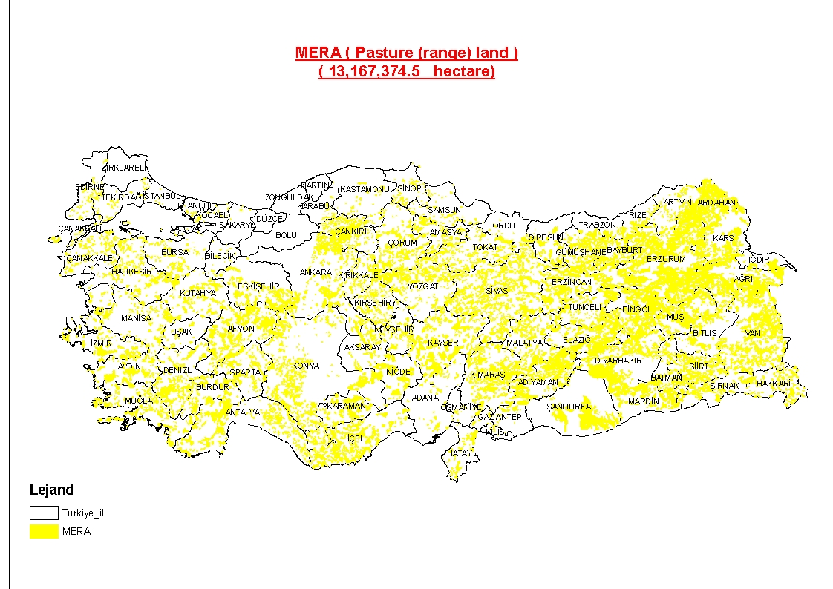
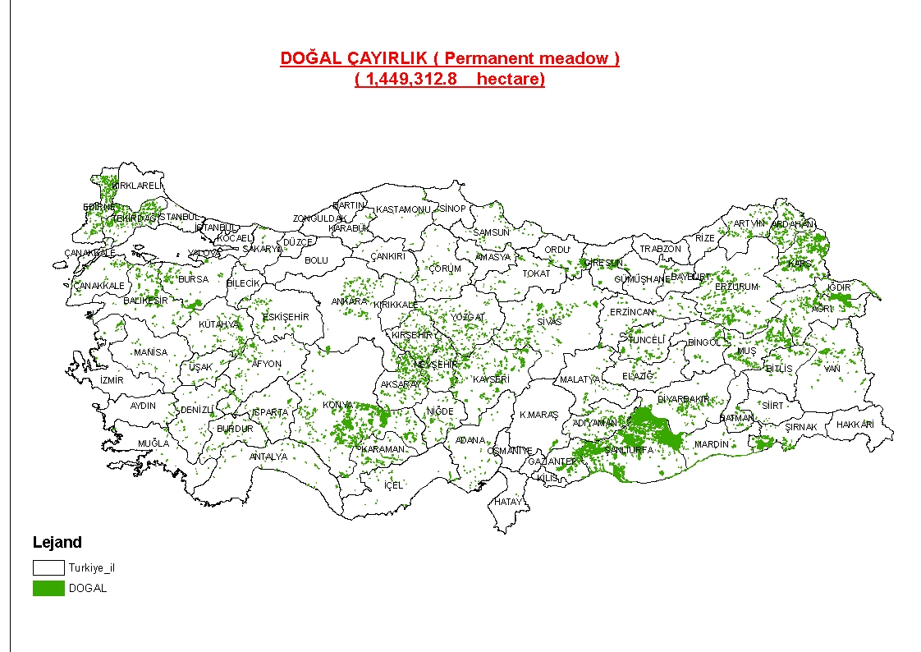
Fig.4.1 Country-wide spatial distribution for permanent meadows and pasture (range) land

- Additionally, due to support applications on the basic of land parcels and after getting farmers to become conscious via direct images of the GIS environment, getting the main land - according to application - quantified by the Ministry of Agriculture and Rural Affairs advisors on the determining of land will provide a fair and instructive way.

- Public administration benefits.
Advanced IACS would allow better analysis of agriculture and therefore better planning and decision making in this field.

- Impact on Competition:

- Introducing a management system improving the support schemes for permanent crops will prevent market and competition distortions and establish a register for permanent crops, enabling the administration to count trees and evaluate market capacity to prepare in the longer run for negotiations with the EU.

- The reduced leakage will make the system fair and avoid distortion in competition, which relates to the situation where one farmer receives funds including for uncultivated portions of land and therefore is in a more competitive position than a farmer who received funds only for cultivated land.

- Reducing exclusion is another element to reduce competition distortion. In this case farmers that cannot claim support funds are disadvantaged in comparison with farmers that can apply for funds.

- Impact on EU harmonization/accession:
Implementation of Option 2 will definitely have a positive impact on harmonization and accession with EU.

- Impact on Current Regulations and Public Institutions:
There are three draft Turkish acts in order to prepare supervision on agricultural land to keep on improving land identification and National Farmer Registration System. According to the deadline sequence, these are (i) Draft By-Law on Implementation of the Integrated Administration and Control System (IACS) , (ii) Draft Law on Implementation of a Decoupled and Simplified Agricultural Support System, (iii) Draft Law Amending the Law on Agriculture and Rural Development Support Institution. Therefore, IACS is not a separate work, but part of a system of reform to harmonize with EU directives. It is compatible with the current regulation. Besides new laws, the current relevant law will be amended to avoid repetitions and maladjustments in existing legislation.

Risks of Option 2

- It is also worthwhile mentioning the risks of option 2:

- Adjustment to IACS / LPIS acquis before accession. By adopting the main items of the text of the EU regulations before accession, Turkey may risk being obliged to change its legislation in parallel with subsequent EU changes. This might cause quite a big problem, because farmers and administration authorities may get confused and refuse acceptance. However, this risk will be limited because the EU will not very often change these complicated regulations. Once a compromise has been found the EU Commission and the EU Council of Ministers normally hesitate or even resist re-opening negotiations.

- Problem of referring to EU regulations, which might change. The implementation in line with EU IACS / LPIS acquis before accession is quite another approach than the members of the EU regularly use. They only refer to the wording of the EU regulation, do not repeat the relevant text of the EU Regulations and restrict themselves normally to legislative acts arranging the scope, institutional matters, responsibilities and payment procedures, including administrative checks and on-the-spot-controls, as well as audit provisions. By this the member states fulfil the obligations set out for them by EU Regulations. For Turkey, not being yet a member of the EU, this simple reference which accepts also changes in the EU texts is not possible, therefore the Turkish regulations compliant with the EU acquis have to copy the wording of the EU regulations.

V. COMPARING ALTERNATIVE SOLUTION PROPOSALS

Most significant impacts have been quantified in monitory terms to allow for calculation of net benefits for each option, whereas other impacts, which were difficult to quantify, have been assessed qualitatively. The comparison of options, based on costs and benefits, is presented in the table below.

Impacts | Option 1: Do nothing | Option 2: Implementation and operation of IACS
Cost Benefit Analysis (quantified)
Present value of benefits (for 9 years), mill Euro | none | 538.6
Present value of costs (for 9 years), mill Euro | insignificant | 50.0
Net present benefits (for 9 years), mill Euro | none | 488.6
Other Impacts (qualitative analysis)
Environmental impacts | negative | positive
Social impacts | negative | positive
Impact on administrative burden | negative | positive
Impact on competition | negative | positive
Impact on harmonization with EU | negative | positive
For detailed calculations of benefits and costs see the annex 1.

Recommendation of option

- Option 2 (Harmonize with EU Integrated Administration and Control System (IACS) is recommended as it both solves the problem and achieves the objectives considered in this report, generating net benefits of at least 488.6 million Euros over a period of 9 years. Moreover, it generates other important environmental and social benefits which have been assessed qualitatively in this report.

- The choice of “doing nothing” option is not feasible due to commitments of establishing proper IACS until 2012. Moreover, keeping the current system will maintain and increase leakage of funds and exclusion of farmers. Additionally, as the existing system does not comply with EU standards, after accession Turkey would receive less funds under EU farmers’ support schemes.

VI. CONSULTATION AND PARTICIPATION

A. Determining People and Groups to Consult

- Besides the farmers and their organizations, other institutions were also identified as the main stakeholders in the field of IACS/LPIS implementation, on one side those who are directly influenced by the project‘s intentions and on the other side those who deliver data and information to the system. The following stakeholders have been identified:

- Farmers
- Farmer Advisory Associations
- Agricultural credit cooperatives, agricultural sales cooperatives and other producer organizations
- Union of Turkish Chambers of Agriculture
- Provincial Directorates of MARA
- General Directorate of Land Registry and Cadastral
- General Directorate of Forestry
- General Directorate of Budget and Fiscal Control
- General Directorate for Economic Sectors and Coordination
- Turkish Statistical Institute (TURKSTAT)
- General Directorate of State Economic Enterprises
- General Command of Mapping.

      - Consultation with farmers

- Within the EU project TR0402.08/002, implemented during 2007, two pilot areas were selected to test the new system and consult farmers – Tekirdağ and Ağri. In both pilot zones, a sample of 600 farmers per zone was selected by MARA using the NFRS data of the previous year. Although, the sufficient number of farmers for consultation was defined to be 500, it was preferred to have some additional farmers as a backup in case that some of them would not be available for consultation. The criteria for the definition of the farmers’ sample were:
- Good balance between big farms and small family farms
- Inclusion of big size and small size parcels
- Coverage of all possible types of crops (arable, permanent, forage) and animals
- Inclusion of plots on all possible morphological reliefs
- Inclusion of farmers managing dispersed parcels
- Spread of the whole spectrum of social and educational classes
The data of the selected farmers were delivered by MARA in Microsoft XLS format. For the needs of the project, all the data were integrated into a relational scheme using Microsoft ACCESS database.

- The order of steps for the realization and completion of the consultation with the farmers was:
- Preparation of the background data (pre-printed application forms, printed maps/digital data and their set-up using Quantum GIS software).
- Training of the local MARA staff in the specified procedures for the completion of farmers’ consultation and the usage of the background data and the Quantum GIS software. A manual for consultation with farmers was developed.
- Preparation of a consultation detailed time plan (definition of the district centre or villages that had to be visited at specific date/hours, names of the farmers, place, etc).
- Preparation of sessions for informing the farmers about the scope of the consultation campaign and the required input from their side.
- Execution of the consultation.
- Update of the farmers’ database and input of the parcels attributes data.
- Update of LPIS and precise digitisation of declared parcels’ boundaries.
- Linking the spatial data of the declared parcels with the attributes data stored in the database, analysing the data of consultation.

- In order to be able to evaluate the feedback of farmers concerning the consultation procedure, it was decided to prepare a questionnaire and ask their opinion on the procedure to be applied in future. Also general discussions with them were used as another source for having feedback, especially on current system. The questionnaire used for consultation with farmers is presented in the annex 2.

- In order to contact the selected farmers and, more specifically, to facilitate the location of their used parcels on the orthoimages and register them on LPIS database, consultations were organized in district centres or even with direct access to distant villages. As the participation of the farmers was on a voluntary basis and without any profit interest for them, the whole campaign was based on their good will to cooperate with the consultants.

- Software has been developed for demonstration of all relevant IACS control measures and statistical export data. Furthermore the methodology and description of all functionalities was elaborated and tested in Tekirdağ with a sample of additional fifty farmers (Original sampling unit was composed from selected farmers in the pilot provinces - in total 1000 farmers)

- The feedback of farmers to the questions related to IACS system was mostly positive. The analysis of their answers is presented in the annex 3.

    - Consultation with other stakeholders

- During the EU project TR0402.08/002 duration of 8 months, a Steering Group was established to deal with implementation of IACS system. The Steering Committee had representatives from the following institutions as members:
- MARA (chairman),
- Ministry of Public Works and Settlement, represented by the General Directorate of Land Registry and Cadastral,
- General Command of Mapping,
- General Directorate of Budget and Fiscal Control,
- Prime Ministry, Undersecretary of Treasury, represented by the General Directorate of State Owned Enterprises,
- Prime Ministry, State Planning Organization, represented by the General Directorate for Economic Sectors and Coordination,
- Ministry of Environment and Forestry, represented by the General Directorate of Forestry,
- Prime Ministry (since September 2007 Ministry of Foreign Affairs), General Secretary for EU Affairs, represented by the Department of Agriculture and Fisheries,
- Union of Turkish Chambers of Agriculture,
and representatives of:
- the EU Delegation to Turkey and
- the Contracting and Financing Authority (CFCU) as observers.

- The Steering Committee convened its sessions three times and submitted highly appreciated comments to raise the project’s performance and its relevance for Turkey.

- Following some suggestions from members of the first Steering Committee the team, with the assistance of the managing unit, set up an Ad Hoc Group as an advisory audience where the team could demonstrate its findings and discuss suggestions. The Ad Hoc Group met four times. In the last meeting the main findings of the project were presented und thoroughly discussed.

- Within the scope of the Leader Farmer Project, farmers established Farmer Advisory Associations and employed agricultural advisers through associations. These advisers provide agricultural extension services. At the moment there are 11 Farmer Advisory Associations active in different locations. Besides, agricultural credit cooperatives, agricultural sales cooperatives and other producer organizations have provided extension services to their members depending on their establishment legislations. These associations will be consulted during the public consultation of RIA Report.

- Later, after the completion of EU project TR0402.08/002, in November 2008, MARA established a working group to carry out this Regulatory Impact Analysis. The working group included representatives from different MARA departments, Prime-ministry and international experts. The work on the document was carried out until June 2009. The working group met every month to discuss the findings and coordinate the work.

- Consultation with MARA province staff. In order to have a more accurate assessment of leakage and exclusion, in April 2009, MARA staff from all 81 provinces was consulted. They had to complete a questionnaire, the main questions being to provide estimates of leakage and exclusion in their region. The questionnaire and results of this consultation are provided in annex 4. The results of this consultation were used in the problem definition section.

    - Final General Consultation

- In order to make the regulatory process transparent, and to gather further comments and opinions on this RIA Report, MARA published the draft RIA and Draft regulation on MARA’s web site for public consultation. The web site allows for feedback by providing the e-mail address of the contact person. The public is expected to provide feedback during one month.

- At the same time, the RIA was disseminated directly to main stakeholders for final consultation:
- Farmer Advisory Associations
- Agricultural credit cooperatives, agricultural sales cooperatives and other producer organizations
- Union of Turkish Chambers of Agriculture
- Provincial Directorates of MARA
- General Directorate of Land Registry and Cadastral
- General Directorate of Forestry
- General Directorate of Budget and Fiscal Control
- General Directorate for Economic Sectors and Coordination
- Turkish Statistical Institute (TURKSTAT)
- General Directorate of State Economic Enterprises
- General Command of Mapping.
With these stakeholders workshops will be organized to gather their feedback.

VII: IMPLEMENTATION AND FOLLOW-UP

A. Implementation

- The main findings in the pilot areas of Tekirdağ and Ağri were that it was possible to implement IACS/LPIS as management tools in areas which are extremely different. Since it was possible to use those tools in such different areas, in that case through simulating application, control and payment procedures for direct payments, then it is also possible to implement these systems throughout Turkey.

- The project got intensive political support because the Turkish Government was aware of the importance of having a reliable spatial database for the management of direct payments to farmers. The country introduced in 2000 the first reform steps in agricultural policy, intensifying it in 2005. First, elements of IACS, like the applications for direct payments, a database comprising farmer’s identity and the agricultural parcels and partly an animal identification and registration system were introduced. But the control was less than foreseen in IACS and integration of the parts was not realized. Therefore, the government expects, with good reason, that the procedures will be accelerated and the misuse and infringements of the direct payment systems visibly reduced.

- Using the data of selected farmers in the pilot area of Tekirdağ (in total 529 farmers), a software has been developed for demonstration of all relevant IACS control measures and statistical export data. A methodology and description of all functionalities was elaborated and tested in Tekirdağ with a sample of fifty farmers.

- In the pilot area applications and payments were simulated for demonstration purposes. But in the whole country real procedures have to be implemented. Therefore, the project recommended developing as soon as possible a single farm payment very similar to the SPS of the EU. The project also made proposals for the structuring of the administration of this single farm payment system with concrete organisation within the Agriculture and Rural Development Support Institution. In other words, the implementation of IACS / LPIS should be provided in parallel to the reform of the direct payment schemes and the competence extension of the Rural Development Support paying agency to manage the direct payments.

- There is also further commitment from EU to provide funding for implementation of IACS system through Turkey.

B. Reviewing Effectiveness of Regulation

- Taking into account the intense harmonization period, the regulation regarding IACS and the system itself will be reviewed every year, in cooperation with stakeholders and the
results will be agreed by all parties. MARA, with the support of relevant experts, will produce annual reports on IACS implementation and functioning. If any changes affect the results of this RIA, the document will be revised to identify whether objectives have been achieved and whether any of the risks mentioned above occurred.

- In particular the following issues will be considered:
- Whether the problem that causes enforcement of the regulation continue to exists
- Whether the proposed measures meet the targets
- Whether the impacts of the regulation are compatible with expectations
- Whether unexpected problems and impacts are encountered

ANNEX 1. Calculation of net benefits, million Euros

 | 2009 | 2010 | 2011 | 2012³ | 2013 | 2014 | 2015 | 2016 | 2017⁴
Discount rate¹ | 2.5%
Benefits² |  | 0 | 0 | 0 | 105.3 | 105.3 | 105.3 | 105.3 | 105.3
Present value of benefits | 538.6 | 0 | 0 | 0 | 95.4 | 93.1 | 90.8 | 88.6 | 86.4
Costs
- investment | 0 | 0 | 0 | 12.5⁵ | 0 | 0 | 0 | 0 | 0
- operation | 0 | 0 | 0 | 7.5 | 7.5 | 7.5 | 7.5 | 7.5 | 7.5
Present value of costs | 50.0 | 0 | 0 | 11,6 | 6,8 | 6,6 | 6,5 | 6,3 | 6,2
Net Present Value (9 years)⁶ | 488.6 | 0 | 0 | -11.6 | 88.6 | 86.4 | 84.3 | 82.3 | 80.3

¹ – The discount rate is the rate used by the Government when applying it to the unjust support payments made to farmers (AGRICULTURAL LAW, no. 5488, article 23, adopted on 18 April 2006: “Starting from the payment date, unjust support payments shall be reimbursed including the legal interest calculated by taking into account default interest rates stated in Article 51 of Law Number 6183 dated 21.7.1953 concerning Collecting Methods of Public Credits. According to this law the default interest rate is 2.5%”)
² – Benefits are calculated as reduction of 8.1% leakage.
³ – This is the year of completion and launch of IACS.
⁴ – This is the estimated year of Turkey accession to EU, which is an assumption to allow for 9 years calculation in this report.
⁵ – The investment from Turkish State Budget will be made one year before the launch of IACS
⁶ – Net present value is calculated according to the following formula:
NPV =$n$
where Bt and Ct are the benefits (revenues) and costs (expenditures) in each year t, i is the discount rate (rate of interest) and n is the life of the project.

We estimated benefits only until 2017, which we assumed as accession of Turkey to EU for the purposes of calculations in this report. Even before accessing EU, Turkey will receive annual benefits from the new system. If IACS system is not implemented and functional before accession, the EU might allocate much less money within the farmers’ support scheme.

ANNEX 2. The questionnaire used under EU Project TR0402.08/002 to consult the farmers:

Q1. What is your evaluation of this procedure?
□ Positive □ Neutral □ Negative
Q2. What is your evaluation of prepared background materials (forms, maps, GIS viewer)?
□ Very good □ Good □ Sufficient □ Bad
Q3. How was the procedure to fill in pre-printed application?
□ Easy □ Medium □ Difficult
Q4. How was the procedure to locate the parcel on working maps?
□ Easy □ Medium □ Difficult
Q5. Would you appreciate larger (more magnified) scale of working maps in the future?
□ Yes □ No
Q6. Do you think that using in the future only GIS application for the map location will be more useful?
□ Yes □ May be □ No
Q7. What your opinion about submitting only once the application and the declared parcels for all supports schemes?
□ Yes, I agree □ I do not know □ Not useful
Q8. What’s your opinion if the support payment system is simplified; will it constitute an unequal position from the point of different crop producers (farmers) or will it be in favour of farmer?
□ Yes, in favour of farmer □ I do not know □ Not useful
Q9. If your land is additionally supported by the government for keeping the land in environmentally good condition, will you be volunteer to join this program or not?
□ Yes □ No

ANNEX 3. The answers of farmers to main questions from the questionnaire used under EU Project TR0402.08/002

ANNEX 4. The questionnaire used to consult MARA province staff in April 2009

1. What is your opinion on the simplification of the support payment system, will it constitute an unequal position upon the different crop farmers or will it be positive for farmers?

Yes, it is positive for farmers I don’t know It’s no use

2. Do you attend to this programme as a volunteer, when farmers conserve their lands in compliance with the environmental aspects and receive an additional support from the government?

Yes No

3. Are there any wrong support payments stemmed from a variety of reasons on the agricultural support payments implementing in your county?

Yes No

4. In case of a wrong support payment, what is the percentage of these wrong support payments within the total payment?

5. What is the size of land inconvenient to the agricultural production but used for agricultural production? The number of farmers and the amount of support.

6. What is the number of farmers who do not benefit from any supports despite he/she makes agricultural production and what is the size of the land?

Answers:

81 questionnaires have been sent, one to each of those 81 provinces.

Question 1:
- Yes – 57%
- No use – 11%
- Don’t know – 32%

Question 2:
- Yes – 59%
- No – 41%

Question 3:
- Yes – 62%
- No – 37%
Just one non response

Question 4:
- 70% of respondents answered
- The average value of answers is 6.1%

Question 5:
- 51% of respondents answered
- The average value is 12.2%

Question 6:
- 90% of respondents answered
- The average value of answers is 12.3%

